Table of Contents

- Executive Summary

- FGE Improvements 1970-2000

- Modeling and Prototypes: Post 2000

- Implementation Options

- Biological Data Analysis and Benefits

- Operations and Maintenance Issues

- Recommendations

- Post Construction Evaluations

- Glossary

- References

- Appendix A- Biological Data Sets

- Appendix B – SIMPAS Runs
I. Executive Summary

Since the early 1970’s the federal government has been studying the impact imposed by federal Columbia River hydroelectric projects on migrating juvenile salmon. The initial focus was to increase project passage and survival through the development of juvenile bypass systems (JBS) rather than having juvenile fish pass through power producing turbines.

These efforts initiated the development of submersible traveling screen (STS), gatewell orifice passage and turbine intake vertical barrier screens (VBS). These new technologies were retrofitted to existing powerhouses and were included in the design of the Bonneville Second Powerhouse (B2). Initial fish guidance efficiency (FGE) expectations at B2 were 70%, however, measured FGE was much lower with an initial FGE of 25% for both yearling and sub-yearling salmonids. Guidance studies in the 1980’s led to further FGE improvements including: lowering the STS, installing turbine intake extensions (TIE), and installing streamlined trash racks. These efforts improved FGE to 48% for yearling Chinook and 26% for sub-yearling Chinook, but still fell short of the 70% goal at B2.

In 1995, the Corps began to evaluate other potential improvements to increase FGE at B2. Hydraulic modeling, coupled with predation studies, led to the development and implementation of JBS improvements and a low outfall structure.

In 1999, the region agreed to pursue a phased approach and focus on improving guidance and survival by increasing flow up the turbine intake gatewells. Under this new direction, prototype changes were made from 2001 to 2004 at units 15 and 17. These modifications included an increase in VBS flow area, installation of turning vanes to increase flow into the gatewell, addition of a gap closure device to eliminate fish loss at the STS, and installation of interchangeable VBS to allow for screen removal and cleaning without turbine outages or intrusive gatewell dipping.

These prototype changes have shown, through both hydraulic modeling and biological studies, to increase FGE by 21% for yearling Chinook and 31% for sub yearling Chinook. These increases in FGE would thereby be expected to yield an increase in overall project survival by 0.7% for late migrating subyearling fish and 0.3% for spring and summer migrating fish.

Based on these data, it is recommended to implement the prototype changes at B2 across the entire powerhouse (Units 11- 18). The total project cost estimate for full implementation is $19,400,000 and encompasses a four-year program proposed to begin in 2005 and end in 2008. In general, two units would be completed per year during the in water work period.

II. FGE Improvements 1970-2000

In 1970, in response to concerns over the effect additional dams may have on juvenile Pacific salmon during their seaward migration, the National Marine Fisheries Service (NMFS) began investigating means to decrease impact to juvenile salmonids passing through Columbia River turbines. NMFS focused on developing submersible traveling screens (STS) to divert juvenile salmonid migrants into specially designed juvenile bypass systems (JBS), which convey fish to a release point below the dam. Many of the original JBS on the Snake and Columbia River projects were subsequently redesigned and upgraded as additional improvements were made and tested (Mighetto and Ebel 1995), (Whitney et al. 1997).

In 1982, the Bonneville Dam Second Powerhouse (B2) was constructed as the last of nine powerhouses installed on the Snake and Columbia Rivers. The JBS system at B2 incorporated STS, vertical barrier screens (VBS), and orifices in the turbine intake gatewells (See Figure 1).

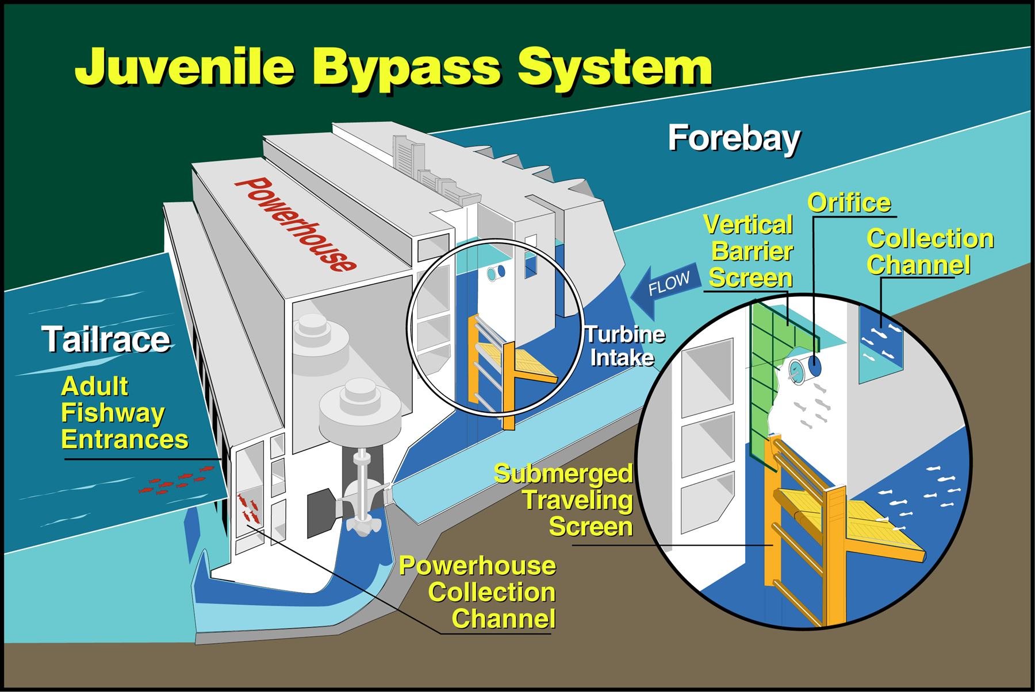
Figure 1: Typical Juvenile Bypass System with STS, VBS and Orifice Shown.

In 1983, NMFS investigated the performance of the newly completed JBS at B2 and measured the mean levels of Fish Guidance Efficiency. FGE measures the percentage of fish guided by the STS into the bypass system relative to the total number of fish entering the turbine intake.
Measured FGE percentages were 25% for sub-yearling and yearling Chinook salmon, much lower than the design goal of 70% for all migrating species.

From 1984-1989, a series of structural modifications were implemented to improve guidance at B2 JBS (Gessel et al. 1991). After years of research in the early 1990’s, the three most promising improvements were installed at B2, that included: the addition of turbine intake extensions (TIEs), lowering the STS, and streamlined trash racks. FGE improvements are shown below in Table 1.

8-9%

8-9%

20%
FGE Increase

Lower STS
Streamlined Trash Racks
Turbine Intake Extensions

Table 1: FGE Increase by TIEs, STRs, and STSs

Research in 1993 and 1994 indicated the FGE improvements for yearling Chinook salmon were improved and ranged from 35 to 60% (Monk et al. 1994-95), however FGE for summer migrant sub-yearling Chinook salmon remained at 25%. Regional goals of 70% guidance for all species were still not achieved.

After publication of the Biological Opinion (BiOp) in 1995, the COE began to evaluate the potential for improving survival through the B2 JBS. NMFS studies documented low survival rates for sub-yearling Fall Chinook passing through the B2 JBS and tailrace, relative to fish released 2.5 km downstream (Ledgerwood et al. 1990). Hydraulic model studies conducted at Engineering Research and Development Center (ERDC), combined with information on the behavior of the primary predator in the tailrace, the Northern Pike-minnow, led to the development of bypass outfall criteria to minimize predation in the tailraces of dams and enhance overall Smolt survival. Criteria developed by Thomas Poe (1993) were used by the COE to design a new low-flow outfall to the B2 JBS. In 1999, a new JBS was completed at B2 that included a downstream migrant channel (DSM), transportation flumes, a juvenile monitoring facility, and an above-water outfall. Biological research studies conducted in 1999-2001 found that the new JBS system had an average survival rate of 98.5%.

The National Marine Fisheries Service (NMFS) was asked by the Corps to study past FGE data and participate in a regional discussion on a path forward for FGE improvements at B2. This effort culminated in a report published by NMFS in April of 1999 that contained a series of recommendations. In November 1999, regional concurrence was reached to pursue a phased approach with initial focus on the intake environment. This report details efforts made in prototyping and developing intake environment improvements.

III. Modeling and Prototypes: 2000-2004

The premise of the studies and prototypes implemented since 2000 is that FGE is improved from increased flow up the gatewell. Significant modeling studies have been completed to develop a hydraulic environment that provides a fish friendly condition in the gatewell with significantly increased flow. These studies included analysis of existing and prototype VBS. The normal velocities on the existing VBS are much greater than accepted NMFS criteria and the velocity distribution is not uniform.

Hydraulic Models

A multifaceted hydraulic modeling effort, including physical, numerical and prototype field measurements, was used for the design of prototype gatewell improvements. These models evaluated water velocities, VBS head loss and debris accumulation for various gatewell configurations.

Several physical models were utilized, including a 1:25 scale sectional model located at ERDC in Vicksburg, Mississippi and a 1:12 gatewell model located at ENSR International in Redmond, Washington.

1:25 Scale Sectional Model

This model reproduces three bays of a typical powerhouse unit. Included in the model are trashracks, STS, VBS, emergency closure gates, scroll case area and approximately 600 feet of B2 forebay topography. In addition, the model is designed to accommodate introduction of lateral flow. This model was used in the hydraulic design of the prototype turning vanes and gap closure device. Water velocities and flow patterns approaching the fish screens, gatewells and turbine intake were collected. Figure 2 shows the flow path represented by dye released into the 1:25 sectional model. This model was used as the starting point to develop modifications capable of increasing gatewell flow. Because of its small scale, it is not suitable for detailed investigations of the VBS and gatewell hydraulic environment.

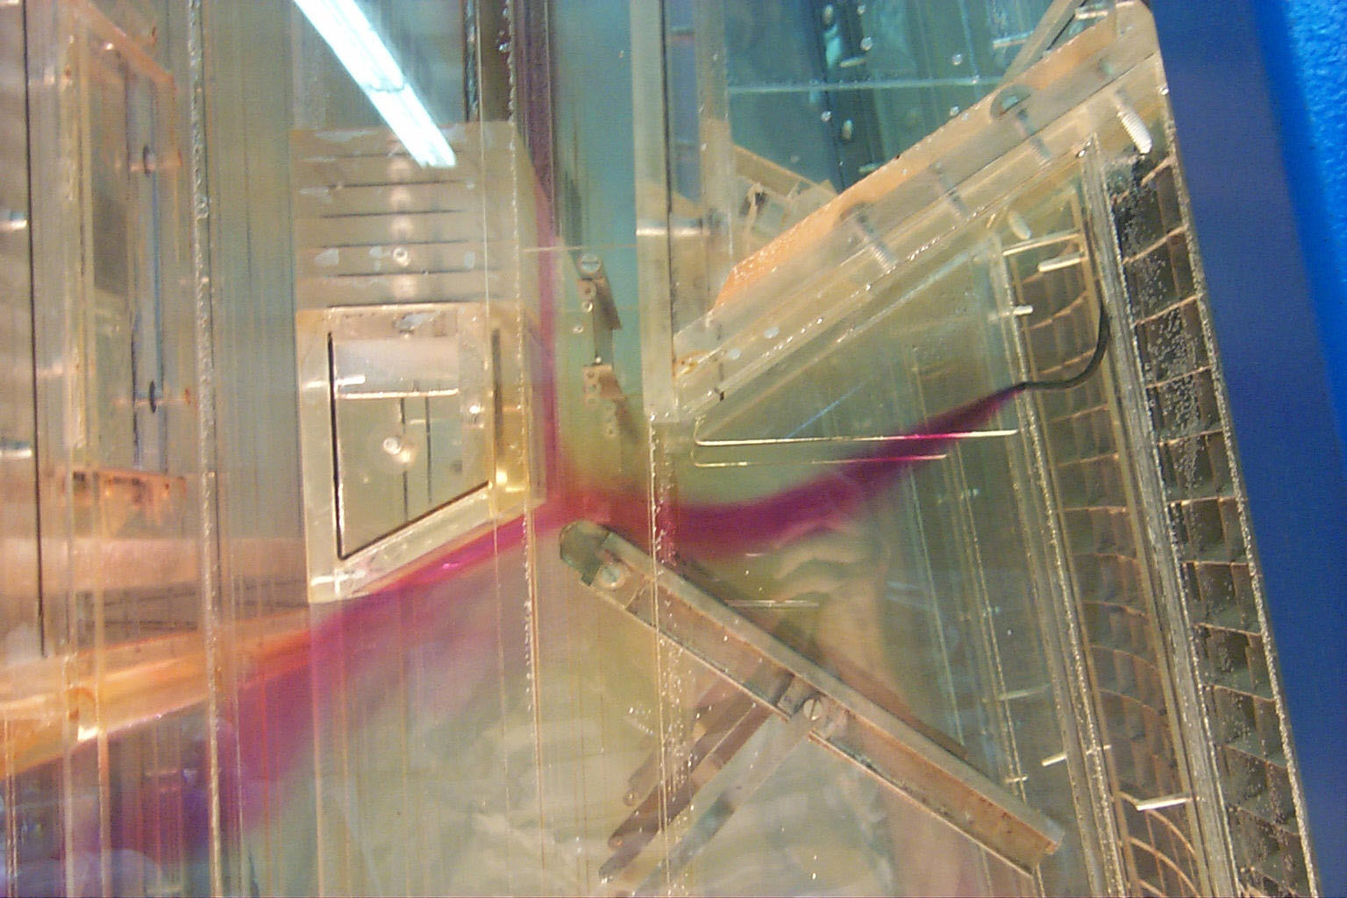

Figure 2: Typical dye release representing path of flow in the 1:25 sectional model
Note: flow through the gap between the STS and intake beam.

1:12 Gate Slot Model

This model represents in cross section, a single intake bay of a turbine unit, gatewell, STS, VBS and approximately 200 feet of forebay approach (see Figures 3 and 4). This model was primarily used to determine the optimum VBS configuration, perforated plate porosities and investigate the gatewell hydraulics associated with the design. This model was also used to investigate the effect debris loading on the VBS has on the gatewell and VBS hydraulics environment.
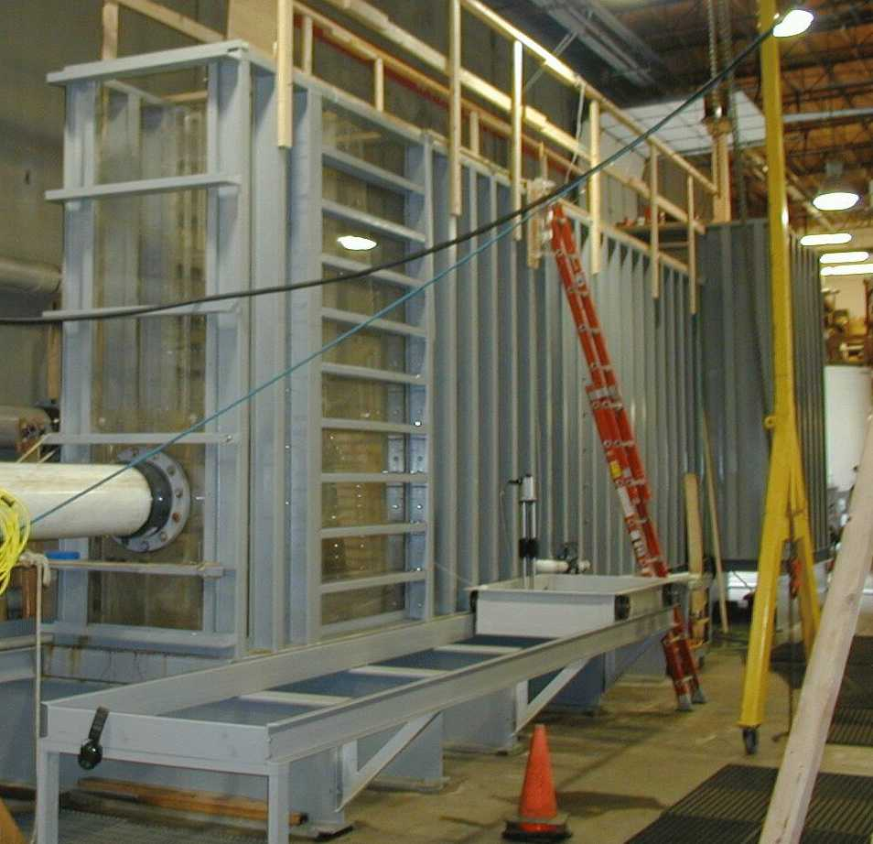
Figure 3: Overview of 1:12 Gate Slot Model
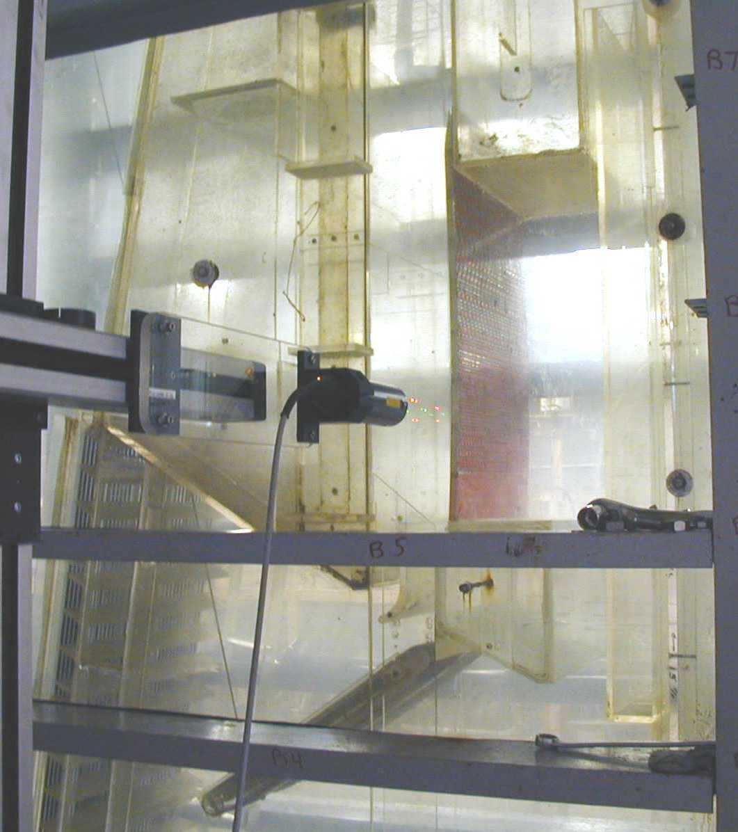

Figure 4: 1:12 gate slot model with laser doppler velocimeter (center) in position

Numerical Modeling

Three-dimensional computational fluid dynamics (CFD) were used on a limited basis to analyze forebay hydraulics and lateral flow conditions approaching B2. STAR-CD code was used to simulate the hydrodynamics of the B2 forebay and intake, including TIES and the STS. The simulations were verified using physical model and field velocity data.

Prototype Field Measurements

In 2004, prototype velocity measurements to quantify gatewell flow were conducted in 2004 at Unit 17. Measurements were made using one-dimensional impeller-type current meters. The data was used to verify velocities taken from the 1:12 gateslot model. Prototype data was also used in the development of curves relating to VBS debris blockage to flow up the gateslot.

Model Study Results

The goal in the design of the VBS is to maximize the amount of flow up the gate slot while maintaining acceptable flow velocities through the VBS. Porosity plates accomplish proper flow distribution through the VBS. With the current fish screen and VBS configuration at B2, approximately 270 cfs is being diverted up the gate slot. Modeling shows that a flow of 490 cfs could be achieved with the modified gate slots and profile wire VBS.

Turning vanes are placed near the entrance of the gatewell, as shown in Figure 5. Hydraulic model investigations have shown that these devices help direct and increase flow up the gatewell.

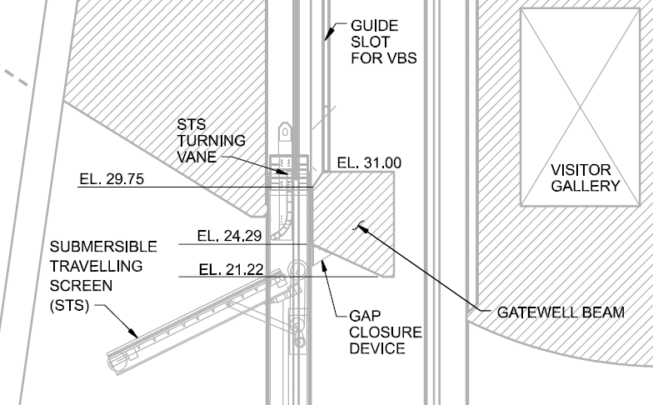

Figure 5: Gatewell entrance with turning vane and gap closure device. Implementation modifications remove chamfer on intake beam at el. 31.

Physical model studies of an existing turbine intake show that installation of a gap closure device alone can reduce the gap discharge by 44%. Installation of a gap closure device in combination with a turning vane reduces gap flow by 55%. A reduction in gap flow of 67% has been achieved with the 2004 profile wire prototype VBS, as illustrated in Table 2. Most importantly, the installation of a gap closure device, with out other gatewell improvements create adverse gatewell hydraulic conditions.

Gap and Gate slot Discharge Comparison | Gap Device Height | Turning Vane Installed ? | Gap Flow  (cfs) | Gate Slot Flow (cfs) | Comments
Unmodified Unit¹ | no | no | 215 | 272 | Intake beam @ el. 37
 | 2 ft | no | 120 | 355 | Intake beam @ el. 37
 | 2 ft | yes | 96 | 441 | Intake beam @ el. 37
Prototype Configurations² | 2 ft | yes | 96 | 480 | 2001 VBS Proto., 6 ft lowered intake beam, chamfered corner
 | 2 ft | yes | 70 | 490 | 2004 Interchangeable VBS Proto. 6 ft lowered intake beam
B2 Onsite Prototype Configuration | 2 ft | yes | Could not meas. | 500 | 2004 Interchangeable VBS Proto. 6 ft lowered intake beam
1 Data from 1:25 sectional model at ERDC.
2 Data from 1:12 gate slot model at ENSR

Table 2: Gap and gatewell flow comparison

Due to the VBS structural damage in 2002 caused by excess debris load, CH2M-Hill performed an alternatives study to address VBS cleaning and debris handling. This study recommended further development of a full height interchangeable profile wire VBS. The alternative consisted of two identical VBSs with stainless steel profile wire oriented in the vertical direction. Two individual slots are used, an upstream slot for the permanent VBS and a downstream slot for the temporary VBS. The upstream slot serves as the permanent VBS location the most favorable hydraulics; the face of this VBS is flush with the intake beam.

When head loss across the screen indicates that the VBS requires cleaning, the second, or temporary VBS is placed in the downstream slot behind the permanent VBS, as shown in Figure 6. The permanent VBS is removed, cleaned, then reinstalled and the temporary VBS is removed.
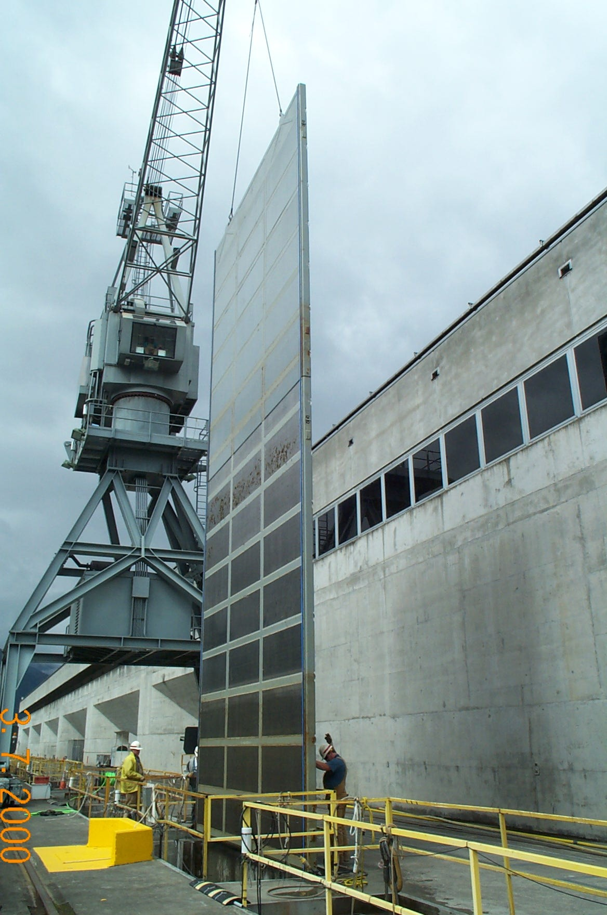
Figure 6: Interchangeable VBS being removed from unit 17

The 2004 profile wire VBS yielded average normal velocities from 0.38 ft/s – 0.73 ft/s.
Figure 7 is a graphical comparison of the velocity distribution for the Original VBS, the 2001 Prototype VBS, and the 2004 Prototype VBS.
Figure 7: Comparison of Velocity Distributions Between Prototype VBSs and Original VBS.

Debris Loading

Results from a debris modeling investigation indicate that debris loading on the VBS impacts the quantity of flow up the gatewell as indicated in Table 3. This is an important consideration in terms of FGE (more flow, more fish). Other considerations are STS hydraulics, and operations and maintenance requirements to manage the debris load for structural concerns. A relationship between water surface differential and gatewell discharge for various VBS blockages has been developed and is shown in Figure 8.

Intake Bay Flow (cfs) | VBS Blockage (%) | Water Surf. Diff. Across VBS (ft) | Gatewell Disch. (cfs)
6,540 | 0 | 0.78 | 490
6,540 | 50 | 0.84 | 460
6,540 | 80 | 0.98 | 420
6,540 | 90 | 1.27 | 340
6,540 | 100 | 1.74 | 0
4,790 | 0 | 0.46 | 370
4,790 | 50 | 0.48 | 360
4,790 | 80 | 0.6 | 310
4,790 | 90 | 0.7 | 240
4,790 | 100 | 0.94 | 0
3,280 | 0 | 0.24 | 260
3,280 | 50 | 0.28 | 250
3,280 | 80 | 0.29 | 220
3,280 | 90 | 0.36 | 180
3,280 | 100 | 0.48 | 0

Table 3: VBS Debris Blockage Effects on Gatewell Discharge

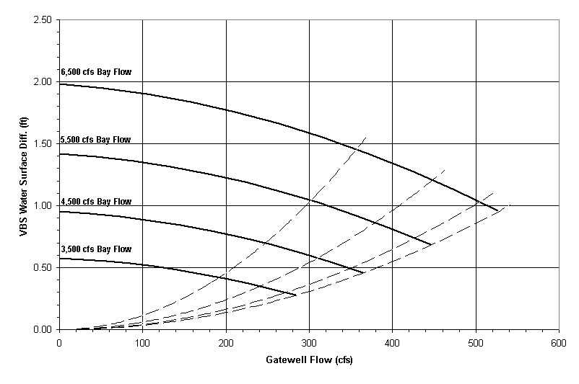

Figure 8: Relationship Between Water Surface Differential, Gatewell Flow and VBS Blockage

Hydraulic Impacts of Gap Closure Device Only

One of the scenarios under consideration was to include a gap closure device only option to improve FGE. As previously discussed, the gap closure device can significantly reduce gap discharge and increase gatewell flow. In addition, the gap closure device is a relatively inexpensive method to increase flow up the gate slot. Hydraulic modeling, however, has shown that the hydraulic environment in the gatewell of an un-modified unit is poor for fish survival. Normal velocities on the VBS are poorly distributed and do not meet accepted velocity criteria. Average normal velocities in some areas of the existing VBS can be close to 2 ft/sec because of the inadequate size of the available VBS flow area. Subsequently, installation of a gap closure device as a singular component was dropped from further consideration.

Lateral Flow in the Forebay

There is a hypothesis that lateral flow may affect FGE at B2. Fish may move along and down the face of the powerhouse, thereby increasing the chances of fish not being guided by the STS. In addition, lateral flow may cause non-uniform flows across the face of the STS. In general, modeling and forebay observations do indicate that lateral flow conditions occur. Forebay approach flow splits at about unit 15 and travels south from units 11 to 14 and north from units 16 to 18. Project operations do influence the magnitude of lateral flow across the Powerhouse. Physical hydraulic models used in the design of prototype FGE improvements did not incorporate lateral flow components. The models used produced approach flow-lines that traveled directly towards and into the intake.

To investigate lateral flow issues in the B2 forebay, three-dimensional CFD models were used. Computer simulations indicate the least amount of lateral flow occurs with the powerhouse operating at full load. There are areas of recirculation near the North and South end of the powerhouse with units at the end receiving larger lateral flow components. Half powerhouse operations produce large lateral flow components across the face of the powerhouse. Computer simulations also indicate that downward flow spirals vertically across the powerhouse from the center of the forebay to the end units. Regardless of powerhouse operations, there is a lateral flow effect in the B2 forebay. The approach bathymetry appears to drive the lateral flow, while the location of the lateral flow varies according to the powerhouse operation.

Prototypes - Structural Improvements at B2

In 2001, several changes were made to increase flow and reduce velocity components normal to the VBS that included: addition of turning vanes and gap closure devices (GCD) in Unit 15, and increasing the VBS opening. Turning vanes were installed in the gate-slot, just above the top of STS to divert more flow up the gate-slot. GCD were mounted on the intake roof just downstream of the STS to prevent fish from traveling through the turbine passage rout. The top 6 feet of the intake beams were removed to increase the VBS flow area by 120 square feet and reduced velocities normal to the VBS.

In 2002, these same structural changes to the VBS were made on unit 17. This unit is subject to a higher degree of lateral flow across the face of the powerhouse as it is an end unit rather than an interior unit, such as 15, with a linear entrance flow. Changes at Units 15 and 17 were both successful in increasing flow, but velocities normal to the VBS were still slightly greater than velocity criteria. In 2003, an effort began to model and implement a VBS with better hydraulic characteristics. The Corps, in conjunction with ENSR and CH2M-Hill, completed a process of brainstorming, modeling, and designing a concept VBS for unit 17 that culminated in an interchangeable, full height VBS with profile wire screens.

Installation of the new profile wire VBS prototypes, in 2004, rounded out the full compliment of changes at unit 17. The modifications have yielded a uniform set of velocities normal to the VBS (0.7 fps) with velocities at or below criteria. This prototype VBS resulted in significant improvements over the existing VBS at B2.

Figure 9: Intake Beam Modifications and Gap Closure Device.

Beam elevation was lowered from EL 37.00 to EL 31.00. The
Gap closure device is shown at EL 24.29

Hydraulic Design

Gatewell and VBS Criteria:

- Average water velocities normal to the vertical barrier screen face shall be a maximum of 1.0 fps.

- Gatewell flow is approximately 10% of the STS intercept flow.

VBS screen material is made of stainless steel with a maximum clear space between each individual bar of 1.75mm.

IV. Implementation Options

There were four options to considered for implementation of FGE improvements at B2:

Option 1, No Implementation: Gap closure devices would need to be removed from unit 15.
Option 2, Full Implementation: Complete improvements across the powerhouse with the full compliment of gatewell improvements and interchangeable VBS.
Option 3, Half Powerhouse Implementation: This option is no longer under consideration. There was an early concern that the increased flow up the gatewells in southern units of B2 would steal fish from the B2CC. Data collected suggest that this is not the case so this option was deleted.
Option 4, Gap Closure Devices Only: This option is no longer under consideration due to unfavorable gatewell hydraulics and high probability for fish injury.

Option One: No Implementation

Although no modifications would be made to the Powerhouse, if the decision were not made to not move forward with improvements, a small amount of work would be completed to remove gap closure devices from unit 15. Gap closure devices in unmodified units create unfavorable gatewell hydraulic conditions and should be removed. The cost to complete this work would be about $275,000. Work to remove the gap closure devices from unmodified units could be completed in one in-water work period.

Option Two: Full Implementation Across Powerhouse

Modifications for option two would include:

  - Add gap closure devices on units 11, 12, 13, 14, 15a, 16, and 18.
  - Modify gatewells to lower the sill six feet and add slots for the interchangeable VBS on units 11, 12, 13, 14, 15a, 16, and 18. Slots 15b and 15c already have lowered sills, but do not have slots for interchangeable VBS.
  - Install turning vanes and interchangeable VBS on units 11, 12, 13, 14, 15, 16, and 18 (unit 15 already has turning vanes).
  - Provide two additional intake-dewatering bulkheads to allow for cost savings and time efficiency for contractors operations. While it will cost approximately $1,000,000 to provide the bulk heads, it is expected that approximately $2,500,000 could be saved with the ability to work in all three slots of a unit at once.

These modifications make units 11 through 18 identical to the prototype at Main Unit 17. An after action review was completed for the prototype at unit 17 after construction. A number of pertinent improvements are outlined in the review that should be incorporated into implementation design.

Plans and specifications for the VBS modifications and bulkheads can be completed in fiscal year (FY) 2005. Contract award would take place early in August 2005 with construction activities in the intakes being completed over three fiscal years (FY 06, 07, and 08). Two units per year could be completed if a construction period of 1 November through 31 March were agreed to through agency consultation.

Program Implementation Cost Data
 | 2005 | 2006 | 2007 | 2008 | Total
BulkHead/Tail Log P&S | $80,000 |  |  |  | $80,000
BulkHead Contract | $1,100,000 |  |  |  | $1,100,000
Tail Log Repair Contract | $400,000
Prototype Implementation P&S | $175,000 | $155,250 | $158,550 | $162,300 | $651,100
Project Support Equipment | $150,000
EDC for Implementation | $50,000 | $113,850 | $73,990 | $75,740 | $313,580
Prototype Implementation CT |  | $5,880,000 | $4,650,800 | $4,760,800 | $15,291,600
Supervision and Administration | $40,000 | $186,300 | $190,260 | $194,760 | $611,320
Total | $1,995,000 | $6,335,400 | $5,073,600 | $5,193,600 | $18,047,600
Cost data adjusted for inflation.

Table 4: Implementation Cost Data
V. Biological Data Analysis and Benefits

POST 2000 FGE Improvements

In 2001, 2002, and 2004, gatewell prototype modifications were implemented in units 15 and 17 that increased FGE and reduced gap loss.

The 2004 studies examined the newly developed VBS and guidance performance in unit 17 as well as gap loss in modified and unmodified units 13 and 17. Initial performance of the new VBS was positive with the new screens showing no mechanical or debris issues. As in 2001 and 2002, gap loss was again measured by way of Dual-frequency Identification Sonar (DIDSON) acoustic camera. Preliminary results during spring peak passage showed a gap loss of 3% in unit 17 compared to 17% in unmodified unit 13.

2000-2003 Data Analysis (Pre Corner Collector)

From 2000-2003 FPE and FGE for B2 were collected with several different biological measurement tools such as radiotelemetry, hydroacoustics and fyke netting (Ploskey- PNNL, Counihan & Adams-USGS, Monk-NMFS). This analysis uses previous baseline (pre 2000 gatewell modifications) FGE data from PH2 for yearling and subyearling Chinook, and steelhead for all units and compares it with FGE data post gatewell modifications. The pre 2000 FGE numbers were 48%, 26%, and 48% respectively. Radiotelemetry, hydroacoustics and fyke netting data from 2000 to 2003 were looked at to quantify the net FGE gain to the three above-mentioned stocks at modified units 15 and 17.

Post 2000 improvements FGE
SPECIES | Baseline FGE | Gap Loss | Corrected Baseline FGE
Yearling Chinook & Steelhead | 48% | 13% | 35%
Sub Yearling Chinook | 26% | 13% | 13%
Table 5: Historic Baseline for FGE at B2

During the analysis we looked at how well fyke netting, hydroacoustics, and radio tag (RT) FGE estimates compared over the same season and over varying water years. On average the comparisons between fyke netting (NMFS) and hydroacoustics (PNNL) were very close and the standard errors were below 3.5%. In the analysis we looked at hydroacoustics (PNNL) and RT (USGS) data and found that large discrepancies between the two data sets were very common which reduced the soundness of the data comparisons with a standard error between the two of 12.3%. For example, fyke netting and hydroacoustic FGE averages were within 5 percentage points for all species for all years. In contrast, hydroacoustics and RT data showed an average spread of 17% over all years and a 22% difference between fyke netting over all years. This trend led us to believe that hydroacoustics and fyke netting were much more closely matched and because of their very tight similarities were given more weight in our data analysis (see Appendix A).

2004 Data Analysis (Post Corner Collector)

In 2004, the Corps continued an aggressive biological research evaluation at Bonneville looking to bolster the survival and passage data sets post corner collection operation. Special emphasis was placed on research programs that would continue to measure standard survival and passage indices for the Bonneville Project along with several new research components aimed at assessing the biological performance of the new B2CC. Hydroacoustic, DIDSON, and RT programs were all used in a research partnership to evaluate and assess the survival as well as route specific species data for juvenile salmonids migrating past B2 and Bonneville Project under 2 spill conditions (50 kcfs 24-h vs. Biop 75 kcfs day/TGD cap night). Special emphasis was placed on measuring the particular nuances on FPE and FGE relative to past years without the B2CC operating.

Radiotelemetry Data

Three radiotelemetry studies were conducted at B2 to measure route specific survival of yearling and subyearling Chinook salmon as well as steelhead. Route specific data for both yearlings and steelhead are presented below in Tables 6 & 7. Although RT was not used for guidance efficiencies, it was deemed appropriate to use for survival estimates.
Route Specific Survival Model Probabilities Yearling Chinook 2004
Juvenile Bypass  System | PH 2  (unguided)  Turbines | Corner Collector | Spillway | PH1 Turbines
97.0%  (94.3, 99.5) | 95.1%  (92.9, 97.2) | 101.6%  (99.9, 100.3) | 91.0%  (88.8, 93.1) | 91.3%  (87.3, 94.9)
Dam Survival = 95.1% (93.6, 96.6)
Route Specific Survival Model Probabilities Steelhead 2004
Juvenile Bypass  System | PH 2  (unguided)  Turbines | Corner Collector | Spillway | PH1 Turbines
95.1%  (90.7, 98.9) | 88.9%  (84.8, 92.7) | 103%  (101, 105) | 97.9%  (95.6,100.2) | 96.5%  (92.6, 99.9)
Dam Survival = 99.1% (97.5, 100.7)
*(Survival Estimate)

Table 6: Radio Tracking Route Specific Survival

This data indicates that the highest route survival for both yearling and steelhead was through the B2CC with a relative survival estimate of 101% and 103% respectively. Also, no significant differences were found between the two differing spill treatments. Route specific survival for fish traveling through the B2 JBS system were also high for the same species at 97% and 95%. Subyearling Chinook showed greater variance in survival under the different routes as well as spill conditions.

Route Specific Survival Model Probabilities Subyearling Chinook 2004
50K vs. BiOp Spill
Juvenile Bypass  System | PH 2  (Unguided)  Turbines | Corner Collector | Spillway | PH1 Turbines
50K  92.9%  Biop  84.0% | 50K  76.0%  Biop  72.4% | 50K  95.5%  Biop  97.0% | 50K  76.4%  Biop  85.6% | 50K  73.4%  Biop  75.4%

Table 7: Radio Tracking Route Specific Survival subyearling Chinook 2004

Highest survival for both spill treatments was through the B2CC with 95.5% and 97.0% respectively. The second highest survival was through the B2 JBS system with 93% and 84%. This study also measured movement, distribution and passage behavior at BON in 2004. Significant findings of the study were: 1) 74% of Steelhead passing B2 did so by way of the B2CC where as yearlings and subs passed at a significantly lower rate of 37%. 2.) FGE at B2 was significantly higher for 2004 compared to 2002 when the B2CC was not operating, 3) All three species of studied fish that previously traveled through B2 turbines and the JBS system exclusively are still traveling through these routes and are not being robbed by the B2CC at a significant rate. These data seem to point out that significant amounts of fish, particularly steelhead, prefer the surface bypass route.

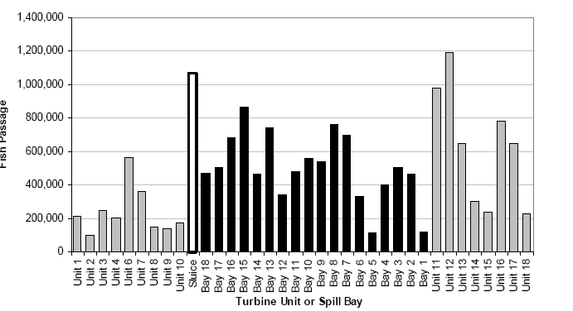

Figure 11: B2 Horizontal Hydroacoustic Distribution 2002

Hydroacoustics, Distribution, and FGE Results

The DOE/PNNL 2004 research program consisted of a detailed look at FGE and vertical distribution of juvenile salmonids at PH2 along with the effects of the B2CC with the absence of Turbine Intake Extensions (TIES) from units 11-14. Initial research indicated that FGE was significantly higher in those units that have been modified and that have gap closure devices. Powerhouse distribution data showed a higher FGE in the modified units in general (15&17) compared to unmodified units across the powerhouse (figures 11 & 12). Summer FGE estimates also show an increase in FGE for migrants during the summer months in modified units when FGE historically falls off later in the season. Horizontal distribution in 2004 was extremely skewed towards the B2CC with over 2 times more fish being
Figure 12: 2004 Horizontal Distribution

Figure 13: 2004 Hydroacoustics B2 FGE

guided into it than the highest unit in the spring (unit 18) and over 3 times as many during the summer as with the highest passage unit 13. Historical passage data shows that units 11 & 12 traditionally and consistently had the highest number of fish passage through the passage season (Figure 11). This effect was attributed to fish that were shoreline oriented as well as these end units being operated as “last off, first on” due to powerhouse priority and adult attraction benefits in the PH2 tailrace. In contrast, units 11 through 13 in 2004 with the B2CC operating show a major shift towards a more even distribution. The 2004 data also shows a significant propensity for passage at unit 18 in the spring, which is a major shift from the norm (figure 12).

Gatewell Modifications and Gap Loss

During the hydraulic modeling evaluations, a high proportion of colored dye representing flow was observed exiting the gap between the top of the intake and the end of the STS (see Figure 2). B2 FGE fyke netting conducted by NOAA (Monk 1999-2000 identified that low numbers of fish were being captured in the gap net that fished this gap. The high volume of flow identified moving through the gap and very low fish collected in the NOAA gap nets raised suspicions about the validity of the fyke netting results. In 2003, the Corps imitated a study to use DIDSON technology to view the turbine ceiling gap environment and to see if we could readily identify and quantify fish passing through.

As mentioned in the prototypes section, unit s 15 and 17 were modified to allow more water up the gatewell slot to introduce more fish to the gatewell and JBS systems as well as installing a gap closure structure to reduce fish loss through the gap between the STS and intake beam. In 2003, units 13, 15 and 17 were examined during both spring and summer for gap loss. After determining that the DIDSON camera was also detecting non-fish objects like waterlogged sticks and other aquatic debris during the study, the data was reexamined and filtered accordingly to remove this debris bias from the samples. Tests concluded that gap loss was found to be approximately 3-4 times as much in an unmodified unit than units with a TV and GCD’s. Unit 13 showed in the spring an average gap loss of 11% compared to units 15 & 17, which showed an average of 3.5%. Summer results were consistent with spring results, showing a higher gap loss in unit 13 than 15 & 17 with 10% and 3% respectively.

Both units 13 and 17 we evaluated for gap loss in the spring of 2004. Gap loss shows a steady 3% during spring for the modified units where as the unmodified units consistently show higher losses ranging between 11% in 2003 and up to 15% in 2004.

Figure 14: Gap Loss Data for 2003 and 2004

Decision Criteria and Anticipated Benefits

For the B2 FGE improvements program, five distinct and measurable objectives were identified to assist the region in formulating a sound basis for and implementation decision (Table 8). From 2000-2004 the Corps developed a research scope to measure B2 FGE improvements with fyke netting, hydroacoustics and radio tags. DIDSON technology was developed to monitor and quantify the improvements from adding a Gap Closure Device to minimize the loss of juvenile salmonids. In 2004, the B2CC was operated in conjunction with the JBS system for the first time. This allowed measurement and quantification of the effects and efficiencies of the newly constructed surface bypass route.

Yes
Improve O&M of screens & gatewell?
Yes, screens within criteria & closer to meeting fry criteria
Improve gatewell environment?
Yes
Increase gatewell flow?
Yes
Improve FGE?
Yes, Mar – Aug: (0.1- 0.3%)
Yes, Sep – Oct: (0.7%)
Improve Survival?
OBJECTIVES MET (YES/NO)
PROJECT OBJECTIVES

SPECIES | LISTED STOCKS
SUMMER CHINOOK | Upper-Columbia
FALL CHINOOK | Upriver Bright  Priest Rapids & Ringold Springs Hatcheries  Hanford Reach Natural  Yakima River & Marion Drain  Snake River Bright  Listed Wild Snake River  Unlisted Lyons Ferry Hatchery  Unlisted Nez Perce and Big Canyon Hatcheries  Mid-Columbia Bright  Deschutes River  Klickitat River  Umatilla River  Little White Salmon River

Table 8: B2 FGE Project Objectives

Table 9: Impacted Stocks

Biological Benefits: Option 1

There are no increased biological benefits to the “no implementation” option, and in fact there are known biological losses from the previous baseline FGE assumptions due to the gap loss phenomenon. If the status quo at B2 continues then a loss of 13% of guided fish or higher is expected at all unmodified units thus reducing current FGE assumptions for all three species. We can also deduce that stocks of later migrating sub-yearling Chinook salmon will have a lower FGE as well. Significant benefits to both FGE and survival for fish passing during spill and post spill can only be realized if the full compliment of FGE modifications is implemented across B2.

Biological Benefits: Option 2, Full Powerhouse Implementation

With more flow up the slot due to gatewell improvements, FGE is being improved (0.1% - 0.3%) for all three species (yearling, subyearling and steelhead) in the modified units during the regular spill season (April through August). A more significant FGE increase of 0.7% was measured for subyearlings after spill is terminated (Sept 1). Table 9 lists affected subyearling stocks that would be aided with the VBS modifications.

The addition of a GCD to these modified units has reduced salmonids being lost through the gap and passing through turbines. This gap loss translates into a direct reduction of more than 13% less than modified units.

Other Positive Factors
In addition to the biological benefits of the turbine intake modifications, additional benefits to the hydropower project would be realized. Regional salmon managers and the Corps agree that the proposed improvement strategy is a positive step towards achieving operational flexibility of the FCRPA, specifically how Bonneville Dam could be better managed to pass migrating juvenile salmonids and improving the varying operational scenarios available during all times of the year.

Provides a more robust Bonneville Dam Project Operational Configuration

B2 FGE improvements can bolster the set of operational configurations that can benefit out-migrants over a wide spectrum of river conditions. Increasing flexibility to operate B2 during both the spill and post-spill seasons while also increasing survival enhances the ability to manage known and unknown environmental and operational conditions. This flexibility is key to providing better or improved survival conditions during reduced spill or no spill events during drought years. As we see from the 2004 RT route specific survival study, the spillway, which has historically shown high survival (+98%) can and will show variability in survival according to different spill operations and river conditions (91% RT spillway survival 2004, USGS). Robustness of routes of project passage helps offset this variability in specific route passage.

SIMPAS Project Survival

New Spreadsheet Model for Fish Passage Survival Estimates (SIMPAS) prediction model data sets for varying spill conditions (75-150K) were tabulated to produce new project survival estimates for fish during the spill season and post spill operations.

SIMPAS PROJECT SURVIVAL ESTIMATE (B2 Priority)
SPILL | Species | Baseline | Full PH (11-18) | Survival Increase
75 kcfs | Yearling | 97.3% | 97.5% | 0.2%
75 kcfs | Steelhead | 98.1% | 98.1% | 0%
75 kcfs | Sub Yearling | 97.5% | 97.8% | 0.3%
120 kcfs | Yearling | 97.5% | 97.7% | 0.2%
120 kcfs | Steelhead | 98.1% | 98.1% | 0%
120 kcfs | Sub Yearling | 97.6% | 97.9% | 0.3%
150 kcfs | Yearling | 97.7% | 97.8% | 0.1%
150 kcfs | Steelhead | 98.1% | 98.1% | 0%
150 kcfs | Sub Yearling | 97.6% | 97.8% | 0.2%

Figure 15: SIMPAS Project Survival Estimate for varying spill conditions.

The data set in figure 15 represents new SIMPAS model runs for varying spill conditions with B2 as the priority powerhouse and the B2CC operating. Project survival increases, although small, are observed in all three runs. The greatest survival benefit was seen in the SIMPAS model runs when spill is terminated on 1 September when late traveling subyearling chinook are the bulk of the out-migrating species. Figure 16 shows subyearling project survival for full implementation verses no implementation and the B2CC operating. The significance of this data is that a substantial survival benefit is captured with and without the B2CC operating. A 0.7% overall project survival benefit to these late traveling subyearling chinook is expected with full prototype implementation and B2CC not operating. The current FPP has B2CC and spill shut off by 1 September. Fish studies in 2005 will determine if the B2CC can be operated without spillway flow. However, the SIMPAS models show a 0.5% project survival increase for full VBS implementation and the B2CC operating.

SIMPAS Project Survival Estimate
FALL CHINOOK – Sep/Oct
(0 kcfs, B2 Priority)

 |  | W/o B2 CC | W/ B2CC | Delta
* B2CC Operation Change | Baseline | 95.4% | 96.7% | 1.3%
Implement Full VBS Modifications | Full PH | 96.1% | 97.2% | 97.2%
 | Delta | 0.7% | 0.5% | 1.8% | Operation Change + VBS Mods

Table 10: Corner Collector Comparison

Baseline FGE |  |  |  | FGE After VBS Modifications
Species | Baseline FGE | Gap Loss | Corrected Baseline FGE | FGE | Gap Loss | Corrected FGE | FGE Increase
Yearling & Steelhead | 48% | 13% | 35% | 59% | 3% | 56% | 21%
Sub Yearling | 26% | 13% | 13% | 49% | 3% | 46% | 31%

Table 11: FGE Comparison between baseline FGE and Prototype FGE

VI Operations and Maintenance

VBS debris cleaning and gatewell debris handling practices on un-modified units require significant commitments of labor and time. One objective of the prototype was to reduce the labor requirements and to increase cleaning effectiveness of the VBS at the B2. In addition, the following factors were deemed important design considerations:

- Maintenance and adjustment of the equipment should be cost-effective and achievable during the annual winter servicing period
- Unit downtime should be eliminated or minimized during cleanup operations.
- Eliminate gate-well dipping requirements for juvenile fish.
- Minimize crane pick and handling requirements.
- Consider screen material durability and ease of cleaning.

CH2M Hill prepared an alternative study that focused on VBS debris cleaning and gatewell debris handling. The alternatives were evaluated on the basis of cleaning effectiveness, capital cost, O&M cost, unit operational constraints and technological risk. The following options were considered:

- Polymesh VBS with Pressure Wash (Existing configuration)
- Traveling Polymesh VBS
- Traveling Profile Wire VBS
- Fixed Profile Wire VBS with Sweep cleaning
- Polymesh VBS with Air or Water Burst cleaning
- Interchangeable VBS
- Polymesh VBS with Vacuum

Traveling VBS are an attractive choice as they are continuously self-cleaning, but have a high capital cost and high O+M cost. Sweeping and air/water burst cleaning was quickly dismissed, as these options merely pushed debris off the VBS and back into the gatewell where it would again become impinged on the VBS. The vacuum system was also quickly dismissed due to concern for juvenile safety. The interchangeable VBS concept was chosen as the most viable option under the evaluation criteria and ultimately served as the prototype for this study.

Prototype Interchangeable VBS

The prototype interchangeable VBS required enlargement of the existing guide slot to accept installation of an auxiliary screen panel. This allows removal of one VBS panel for cleaning on the powerhouse intake deck while the other VBS panel remains in place to prevent fish and debris from entering the turbines. This temporary second screen allows units to continue to operate and frees project personnel from dipping the gatewell for fish prior to removal of the screen. After cleaning of the VBS, the second panel is removed.

The prototype screens were designed to extend above the gatewell water line. These “full-height” panels were developed in response to concerns regarding the complexity and maintenance requirements of sealing the tops of the VBSs to the concrete vertical face of the UMT to prevent fish passage. Full height screens alleviate the potential problem of fish circumventing the VBS and passing through the turbines.

The prototype screens should be pulled and inspected periodically to detect damaged coatings on the frame. The prototype VBS panels should require no maintenance other than periodic coating repairs and re-caulking of caulking around the profile wire panels. The only moving parts to the prototype VBSs are the wheels integral to the frame. The wheels in the VBS frame are a greaseless design and should provide continuous trouble free and maintenance free service.

VBS Cleaning

Cleaning requirements of the prototype screens remain similar to the existing screens, but the prototypes allow a more vigorous (and therefore faster) cleaning and allow cleaning while units are running.

The profile wire offers an advantage in terms of ease of cleaning in comparison to the mesh that is currently in place on the existing VBS frames. The profile wire is more durable and will require less maintenance than the poly-mesh panels and be able to handle a faster and more vigorous cleaning. This translates into approximately $210,000 of savings for the project per year (FY03 dollars, Vertical Barrier Screen Debris Cleaning and Gatewell Debris Handling Alternative Study, CH2M-Hill 2003).

Project operations personnel have had difficulty in getting the existing VBS frames to properly seat on the gatewell beam. This is significant, as debris tends to collect at this location due to hydraulics in the gatewell. The prototype VBS include a neoprene pad at the base of the VBS frames. These pads allow the frames to obtain a seal on the gatewell beam, even when small debris is present.

VII. Recommendations

The biological and hydraulic objectives for the B2 FGE gatewell improvements have been achieved and the following recommendations are made:

- Full Implementation of VBS modifications across B2 (units 11-18).

- Install the full compliment of VBS intake modifications including gap closure devises, turning vanes, bar screens, larger gatewell opening.

- Fabricate two additional intake dewatering bulkheads.

- Modify two units per year. Recommend construction period from 1 November through 31 March. Require three years for full PH implementation (FY06, FY07, FY08).

- Install pressure transducers inside each gatewell to measure drawdown in the gatewell to identify when to clean the VBS.

- Investigate purchase of charge pump to expedite VBS bar screen cleaning by project personnel.

VIII. Post Construction Evaluation

Although the Corps does not believe an extensive post construction-monitoring program is necessary because of the B2 FGE prototype program recently completed, as the implementation of the VBS modifications nears completion, regional consultation will be undertaken to readdress this issue. If warranted, a cost effective fish study will be undertaken using the best-known technologies for concerned species.

X. Glossary

B2 ---------------------- Bonneville Dam Second Powerhouse
B2CC---- Powerhouse Two Corner Collector
BiOp Biological Opinion
BON Bonneville Lock & Dam.
COE --------------------US Army Corps of Engineers
CH0 -------------------- Sub-yearling Chinook Salmon
CH1 -------------------- Yearling Chinook Salmon
CRITFC Columbia River Intertribal Fish Commission
DIDSON ---------------Dual-Frequency Identification Sonar
DOE --------------------Department of Energy
ESA--------------------- Endangered Species Act
Forebay That area of a reservoir immediately upstream of a dam
FGE -------------------- Fish Guidance Efficiency
FPE --------------------- Fish Passage Efficiency
FPC Fish Passage Center.
FPP Fish Passage Plan.
GCD --------------------Gap Closure Devise
JBS Juvenile Fish Bypass System
Kcfs Thousand cubic feet per second
NOAA National Oceanic and Atmospheric Administration Fisheries
ODFW Oregon Department of Fish & Wildlife
PH1 Bonneville First Powerhouse
PH2 Bonneville Second Powerhouse
PIT ------ Passive Integrated Transponder
PNNL -------------------Pacific Northwest National Laboratory
Project Bonneville Lock & Dam
SIMPAS --------------- Spreadsheet Model for Fish Passage Survival Estimates
SMF Smolt Monitoring Facility
STL or STLD--------- Steelhead Trout
STS Submersible Traveling Screen
Tailwater ------ The portion of river immediately downstream of a dam or powerhouse
TDG --------------------Total Dissolved Gas
TIES Turbine Intake Extension Screen
T/V ---------------------Turning Vane
USGS ------------------ U.S. Geological Survey
VBS Vertical Barrier Screen
WES -------------------- Waterways Experiment Station
WDFW ------- Washington Department of Fish & Wildlife

XI. References

Hydroacoustic Evaluation of Fish Passage Efficiency at Bonneville Dam 2000, 2001 and 2002, 2004 AFEP Draft, Ploskey, Gene PNNL

Passage Behavior of Radio-Tagged Yearling and Sub Yearling Chinook at Bonneville Dam 2001, 2002 and 2003, Adams et al, USGS

An Evaluation of the Biological Database of Improving Fish Guidance Efficiency at Bonneville Dam Second Powerhouse April 1999, Monk, Gessel, Ferguson NMFS

Evaluation of Turbine Intake modifications at Bonneville Second Powerhouse Main units 15 and 17, 2001 & 2002. Monk, NMFS

The Bonneville Decision Document 2002, USACE Portland District

Evaluation of Fish Losses through Screen Gaps at Modified and Unmodified Intakes of Bonneville Dam Second Powerhouse in 2003& 2004 AFEP Draft, Ploskey, Weiland. PNNL

Estimating the Survival of Migrant Juvenile Salmonids through Bonneville Dam using Radio Telemetry, 2004 USGS Hardiman, Jill

Movement, Distribution, and Passage Behavior of Radio-Tagged Juvenile Salmonids at Bonneville Dam Associated with FPE and Survival Test, 2004 AFEP Draft, Adams, Noah USGS

Survival Estimates of Sub-Yearling Chinook Salmon through Bonneville Dam using Radio Telemetry, 2004 AFEP Draft, Counihan, Tim, USGS

Fish Guidance Efficiency Improvements Bonneville Second Powerhouse Final Report (B2 FGE Program, Oct 1999. INCA, COE, BioAnalysts, Chinook Engineering, ENSR, and R2 Resources

Bonneville 2nd Powerhouse Fish Guidance Efficiency Improvement Study Final Report, INCA Engineers, December 1999

Bonneville Dam Post Spill Subyearling Chinook Smolt Passage Index, Kim Fodrea, BPA, Personal Communication 1/18/05.

Bonneville Second Powerhouse Fish Guidance Efficiency, Phase II 1:12 Scale VBS/Bulkhead Slot Hydraulic Model; Contract No. DACW57-97-D-003 T.O. No. 010 Final Report, ENSR International

Bonneville Second Powerhouse Fish Guidance Program, Vertical Barrier Screen Debris Model Investigation, Contract No. DACW-57-02-D-0004, Task Order No. 0001, Modification’s No.’s 1 through 3. Vertical Barrier Screen Debris Cleaning and Gatewell Debris Handling Alternative Study, CH2M-Hill 2003

Bonneville Second Powerhouse Fish Guidance Program, Interchangeable VBS Investigation, Contract No. DACW-57-02-D-0004, Task Order No. 1, Modification’s No.’s 4 through 7

Askelson, Sean Memorandum for Record, Bonneville 2nd Powerhouse FGE – VBS Crossflow, March 12, 2004

Numerical Simulations of the Bonneville 2 Forebay Supporting Fish Guidance Efficiency Improvement Studies, Draft Memorandum For Record, Pacific Northwest National Laboratory

